DIVYAPRAKASH
25AD076
OS LINUX COMMANDS
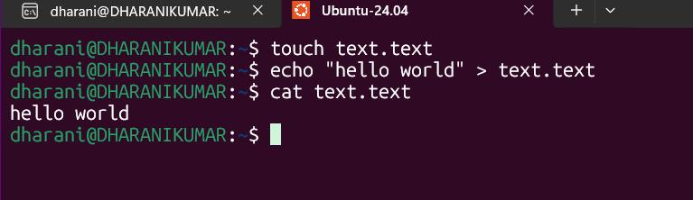
Aim:
To understand the purpose of Linux commands and execute them practically.
Command 1: ls

Definition: Lists files and directories. Result Screenshot:
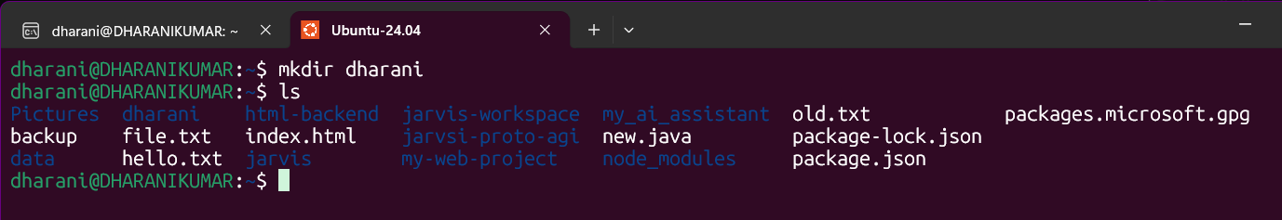

Command 2: pwd
Definition: Checks the current directory. Result Screenshot:
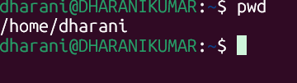

Command 3: tar
Definition: Create or extract archives. Result Screenshot:
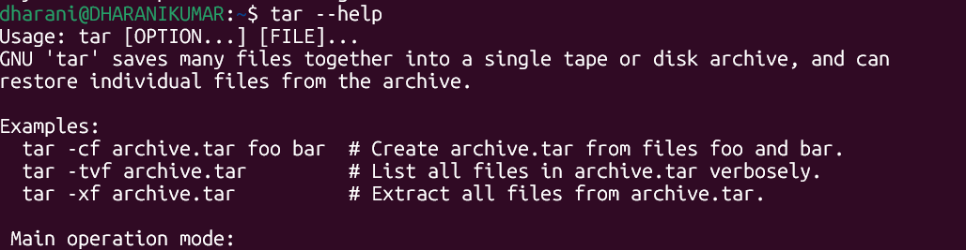
Command 4: mkdir
Definition: Creates a new directory. Result Screenshot:
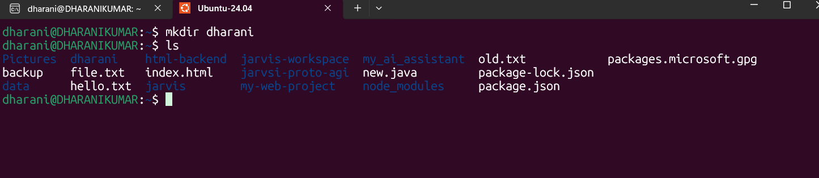
Command 5: touch

Definition: Creates an empty file. Result Screenshot:

Command 6: cp
Definition: Copies files or directories. Result Screenshot:

Command 7: mv
Definition: Moves or renames files. Result Screenshot:
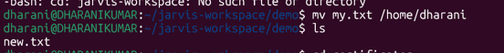

Command 8: rm
Definition: Removes files or directories. Result Screenshot:
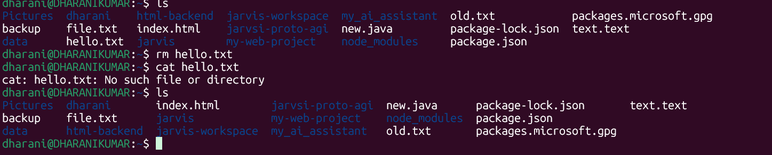
Command 9: which
Definition: Find the path of a command. Result Screenshot:
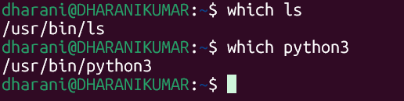

Command 10: head
Definition: Shows the first 10 lines of a file. Result Screenshot:
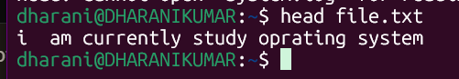

Command 11: wget
Definition: Download files from internet. Result Screenshot:
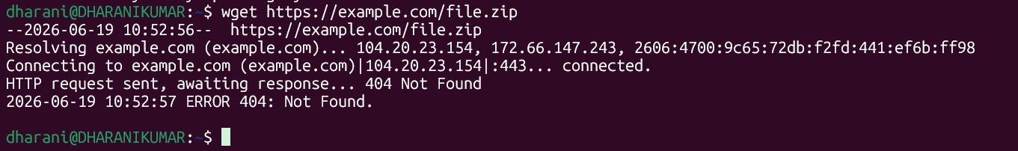

Command 12: grep
Definition: Searches for text in files. Result Screenshot:

Command 13: chmod
Definition: Changes file permissions. Result Screenshot:


Command 14: whoami
Definition: Displays the current user. Result Screenshot:
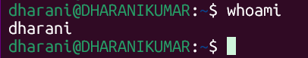
Command 15: date

Definition: Shows current date and time. Result Screenshot:


Command 16: df -h
Definition: Displays disk usage. Result Screenshot:
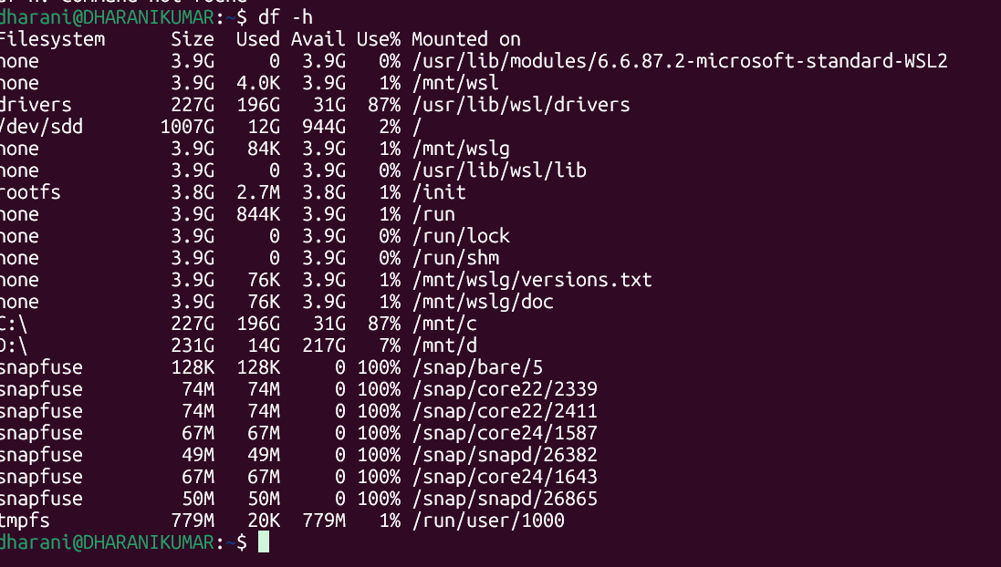

Command 17: kill
Definition: stop a running program. Result Screenshot:

Command 18: uname
Definition: Displays system information. Result Screenshot:


Command 19: history
Definition: Shows command history. Result Screenshot:
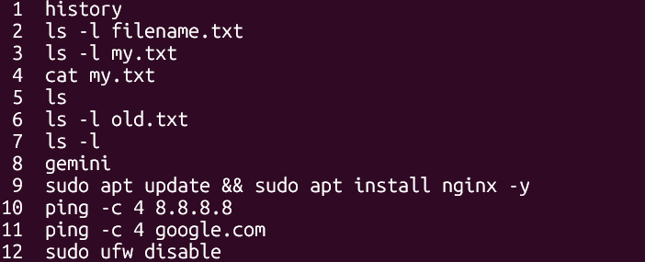
Command 20: chown
Definition: Change the owner. Result Screenshot:
